CREATE TABLE Worker (

WORKER_ID INT NOT NULL PRIMARY KEY AUTO_INCREMENT,

FIRST_NAME CHAR(25),

LAST_NAME CHAR(25),

SALARY INT(15),

JOINING_DATE DATETIME,

DEPARTMENT CHAR(25));

INSERT INTO Worker

(WORKER_ID, FIRST_NAME, LAST_NAME, SALARY, JOINING_DATE, DEPARTMENT) VALUES

(001, 'Monika', 'Arora', 100000, '14-02-20 09.00.00', 'HR'),

(002, 'Niharika', 'Verma', 80000, '14-06-11 09.00.00', 'Admin'),

(003, 'Vishal', 'Singhal', 300000, '14-02-20 09.00.00', 'HR'),

(004, 'Amitabh', 'Singh', 500000, '14-02-20 09.00.00', 'Admin'),

(005, 'Vivek', 'Bhati', 500000, '14-06-11 09.00.00', 'Admin'),

(006, 'Vipul', 'Diwan', 200000, '14-06-11 09.00.00', 'Account'),

(007, 'Satish', 'Kumar', 75000, '14-01-20 09.00.00', 'Account'),

(008, 'Geetika', 'Chauhan', 90000, '14-04-11 09.00.00', 'Admin');

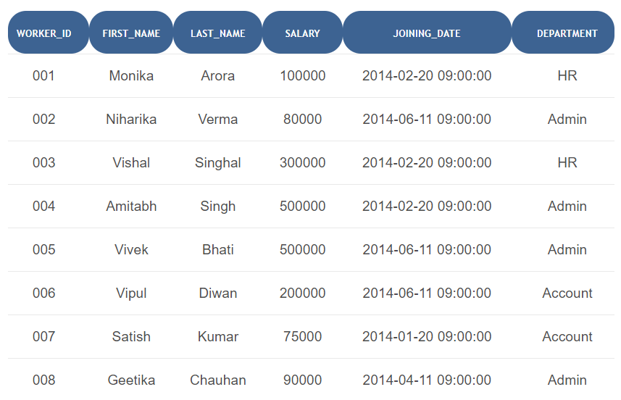

Q-1. Write an SQL query to fetch “FIRST_NAME” from Worker table using the alias name as <WORKER_NAME>.

ANS = Select FIRST_NAME AS WORKER_NAME from Worker;

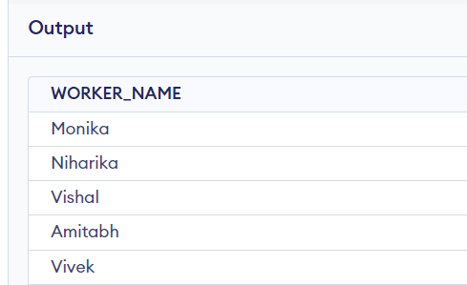

Q-2. Write an SQL query to fetch “FIRST_NAME” from Worker table in upper case.

ANS = Select upper(FIRST_NAME) from Worker; 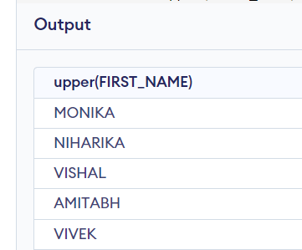

Q-3. Write an SQL query to print the first three characters of FIRST_NAME from Worker table.

ANS = Select substring(FIRST_NAME,1,3) from Worker;

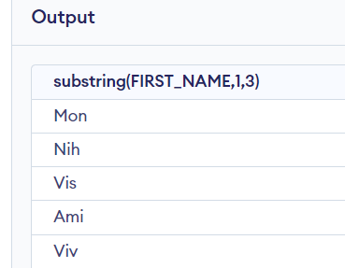 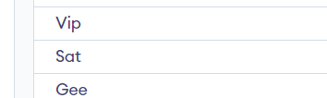

Q-4. Write an SQL query to fetch unique values of DEPARTMENT from Worker table.

ANS = Select distinct DEPARTMENT from Worker;

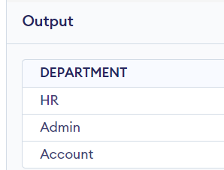

Q-5. Write an SQL query to print the FIRST_NAME from Worker table after removing white spaces from the right side.

ANS = Select RTRIM(FIRST_NAME) from Worker;

